Question: Write a program for linear search.
PROGRAM:
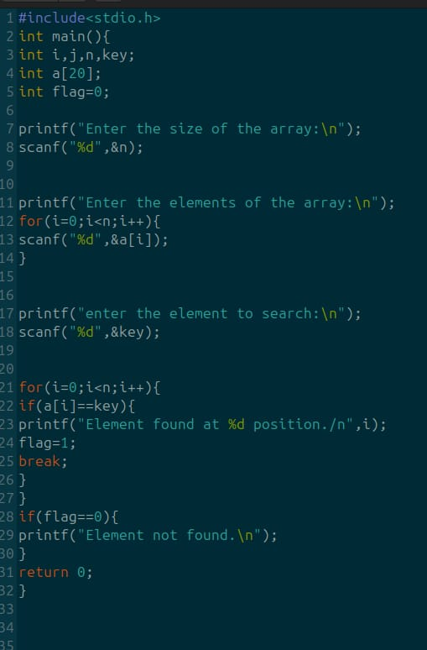
TERMINAL PROCESS:
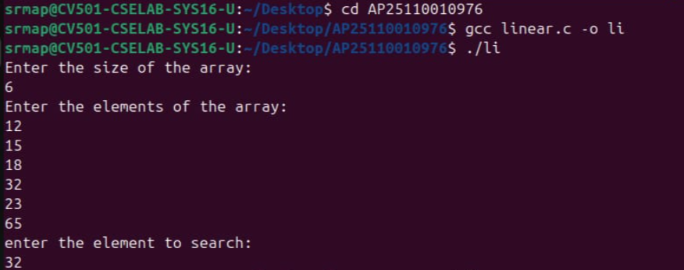
TERMINAL OUTPUT:

_______________________________________________________________________________________________________________________2nd Program______________________________________
Question: Write a program for binary search.
PROGRAM:
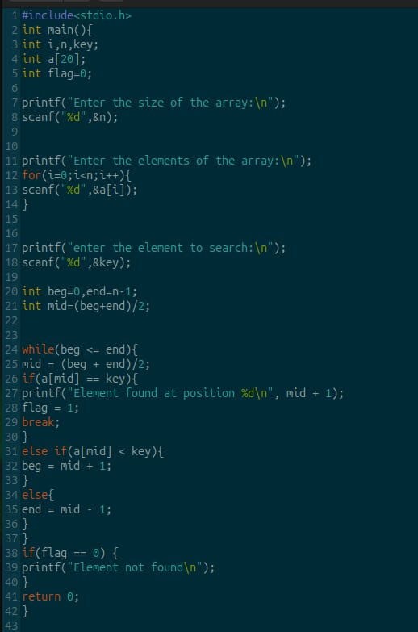
TERMINAL PROCESS (INPUT AND OUTPUT):
